**Pseudocode for NoteBook**

Recap: This is a mobile app designed for users to take notes and store their notes on the local SQLite database. Although there have already been a bunch of apps doing the same job, it is a good chance for me, a beginner android developer to get familiar with android development and its SQLite database. Also, I will integrate the development process with my design skills to make this app distinguished from its competitors.

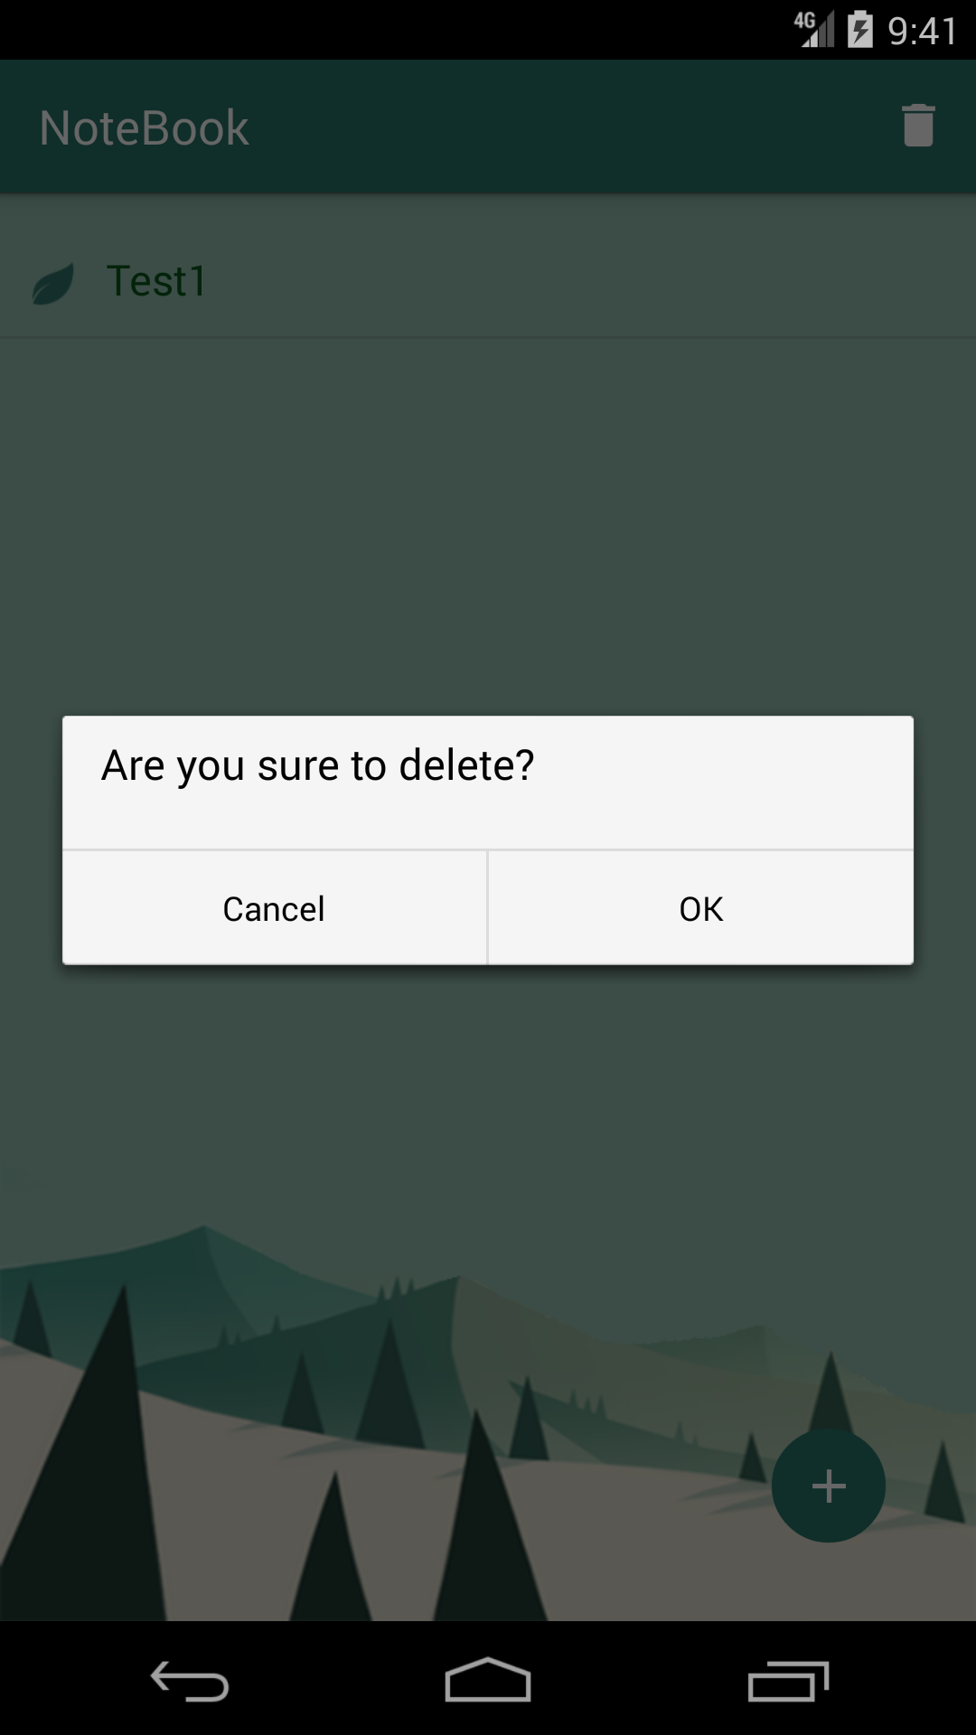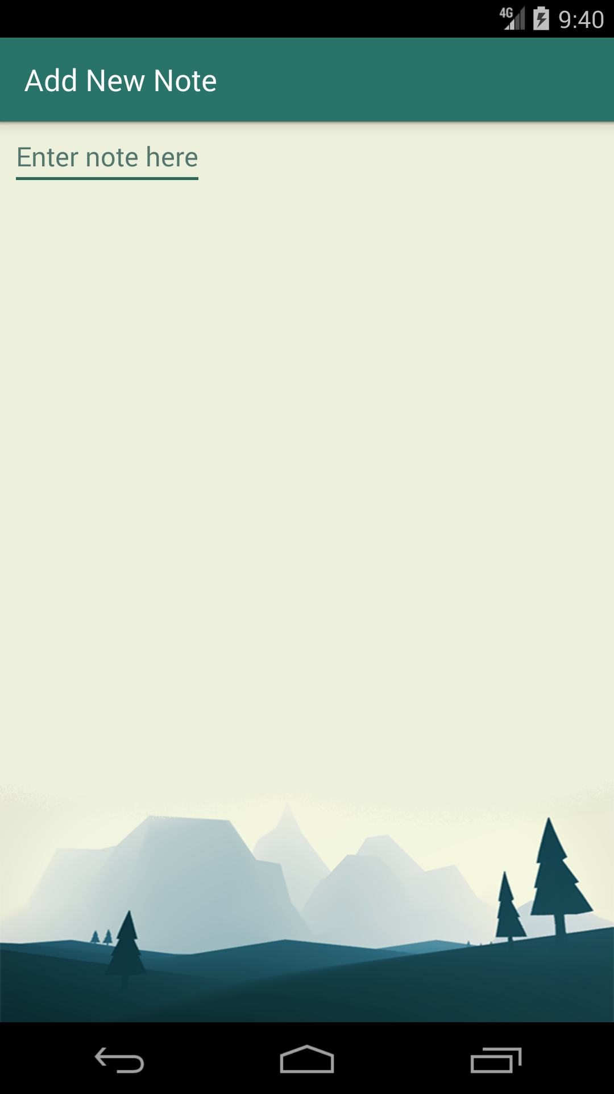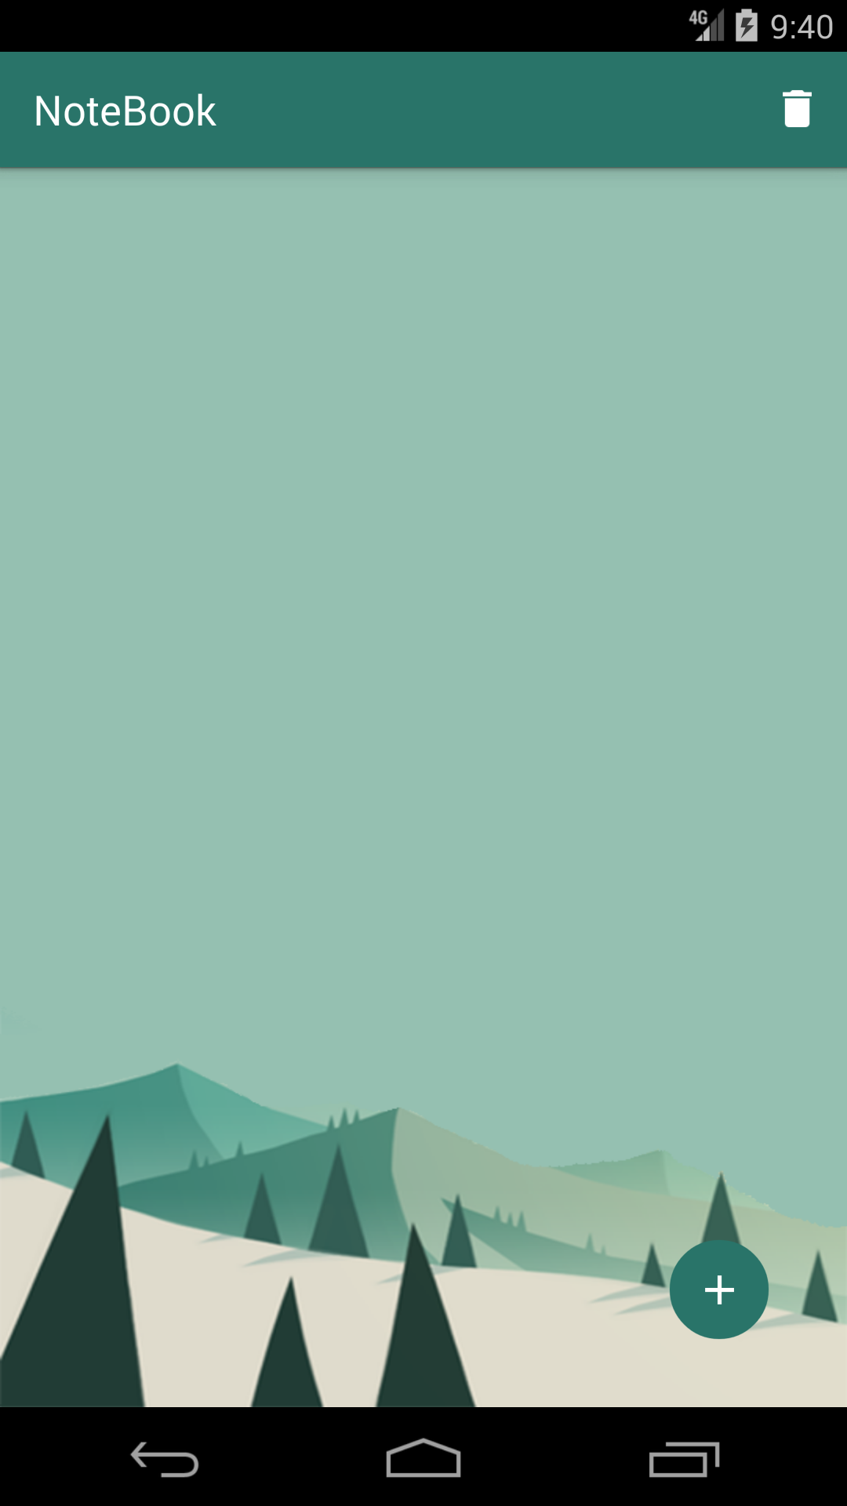

Above are the screens of NoteBook, which give an idea about what it will look like. There are two activities, with the main activity being the home screen for users to add and check their notes, and the other activity being the new notes editor. The trach icon at the right top of the screen indicates that the user could delete all notes with one click. By clicking on each note, the user could get into the second activity to modify or delete it separately.

**Database Setup**

Setting up a SQLite database by creating a new java class called DBOpenHelper and extend it to the SQLiteOpenHelper super class.

For this part, I’ll make a reference to the online tutorial:

<https://www.youtube.com/watch?v=aQAIMY-HzL8>

Managing the database with a content provider to enable inserting, updating, deleting, and querying. Then implementing the content provider class to add Create, Read, Update, and Delete methods to modify the data. Using the Cursor interface to provides read-write access to the result set returned by a database query.

Make a reference to this tutorial:

<https://www.youtube.com/watch?v=eNW1d8tiXmQ>

Creating a Listview to display the data and a floating button at the right bottom to intrigue another activity.

Make a reference to this tutorial:

<https://www.youtube.com/watch?v=Z4Mu6g_M71s>

For the UI design part, I will follow the material design principles and make it a flat style app as shown above. Using icons from Google or other royalty free resources.

*This app is almost finished and needs to get further polished.